AI-Enabled Intelligent Learning System for Personalized Education

A
Project Report
Submitted in partial fulfillment of the requirement for the award of degree of
Bachelor of Technology
In
Information Technology
Submitted to
RAJIV GANDHI PROUDYOGIKI VISHWAVIDYALAYA,
BHOPAL (M.P.)

Guided By Submitted By
Prof. Mahendra Verma Anushka Yadav (0827IT231027)
Himanshu Thakur (0827IT231055)
Aaradhya Sharma (0827IT231001)
Hitendra Singh (0827IT231057)

DEPARTMENT OF INFORMATION TECHNOLOGY
ACROPOLIS INSTITUTE OF TECHNOLOGY & RESEARCH,
INDORE (M.P.) 453771
2025-2026
Declaration
We hereby declared that the work, which is being presented in the project entitled AI-Enabled Intelligent Learning System for Personalized Education partial fulfillment of the requirement for the award of the degree of Bachelor of Technology, submitted in the department of Information Technology at Acropolis Institute of Technology & Research, Indore is an authentic record of our own work carried under the supervision of “Prof. Mahendra Verma”. We have not submitted the matter embodied in this report for the award of any other degree.

Anushka Yadav (0827IT231027)
Himanshu Thakur (0827IT231055)
Aaradhya Sharma (0827IT231001)
Hitendra Singh (0827IT231057)

Prof. Mahendra Verma
Supervisor

Project Approval Form
I hereby recommend that the project AI-Enabled Intelligent Learning System for Personalized Education prepared under my supervision by Anushka Yadav (0827IT231027), Himanshu Thakur (0827IT231055), Aaradhya Sharma (0827IT231001), Hitendra Singh (0827IT231057) be accepted in partial fulfillment of the requirement for the degree of Bachelor of Technology in Information Technology.

Prof. Mahendra Verma
Supervisor

Recommendation concurred in 2025-2026

Prof. Ankita Agrawal
Project Incharge

Prof. Deepak Singh Chouhan
Project Coordinator

Acropolis Institute of Technology & Research
Department of Information Technology

Certificate
The project work entitled AI-Enabled Intelligent Learning System for Personalized Education submitted by Anushka Yadav (0827IT231027), Himanshu Thakur (0827IT231055), Aaradhya Sharma (0827IT231001), Hitendra Singh (0827IT231057) is approved as partial fulfillment for the award of the degree of Bachelor of Technology in Information Technology by Rajiv Gandhi Proudyogiki Vishwavidyalaya, Bhopal (M.P.).

Internal Examiner External Examiner
Name:………………. Name: ……………..
Date: …./…/……….. Date: …./…/………..

Acknowledgement

With boundless love and appreciation, we/I would like to extend our heartfelt gratitude and appreciation to the people who helped us to bring this work to reality. We would like to have some space of acknowledgement for them.
Foremost, we would like to express our sincere gratitude to our supervisor, Prof. Mahendra Verma whose expertise, consistent guidance, ample time spent and consistent advice that helped us/me to bring this study into success.
To the project in-charge Prof. Ankita Agrawal and project coordinator Prof. Deepak Singh Chouhan for their constructive comments, suggestions, and critiquing even in hardship.
To the honorable Prof. (Dr.) Prashant Lakkadwala, Head, Department of Information Technology for his favorable responses regarding the study and providing necessary facilities.
To the honorable Dr. S.C. Sharma, Director, AITR, Indore for his unending support, advice and effort to make it possible.
Finally, we would like to pay our thanks to faculty members and staff of the Department of Computer Science & Engineering for their timely help and support.
We also like to pay thanks to our parents for their eternal love, support and prayers without them it is not possible.

Anushka Yadav (0827IT231027)
Himanshu Thakur (0827IT231055)
Aaradhya Sharma (0827IT231001)
Hitendra Singh (0827IT231057)

Abstract
The AI-Based Personalized Learning and Exam Intelligence System revolutionizes education by transitioning from a rigid, one-size-fits-all model to a dynamic, student-centered environment that adapts to individual strengths, weaknesses, and learning paces. By leveraging a robust full-stack architecture—comprising a user-friendly frontend, high-performance backend, and a centralized database—the platform seamlessly integrates intelligent features like automated study planning, granular performance analytics, and personalized content delivery. These AI-driven components work in tandem to track user progress and provide actionable insights, allowing students to identify specific knowledge gaps and optimize their preparation strategy for examinations. By bridging the gap between traditional pedagogical methods and modern educational technology, the system not only improves study efficiency and academic performance but also fosters deeper student engagement through a structured, data-informed approach to learning. Ultimately, this integration of personalization and advanced analytics empowers learners to move away from reactive studying toward a proactive, strategic academic journey, ensuring they are well-equipped to meet their educational goals with confidence and clarity.

Table of Content
Declaration ……………………………………………………………………………………………………... II
Project Approval Form ……………………………………………………………………………………….. III
Acknowledgement ……………………………………………………………………………………………… V
Abstract ………………………………………………………………………………………………………... VI
List of Figures ……………………………………………………………………………………………….. VIII
List of Tables …………………………………………………………………………………………………... IX
Introduction & Background ……………………………………………………………………………………. 1
Requirements & Planning ……………………………………………………………………………………… 5

System Design & Architecture ………………………………………………………………………………... 11

Methodology / Model Development ……………………………………………………………………..……. 18

Implementation & Testing ……………………………………………………………………………………. 28

Results, Analysis & Discussion ………………………………………………………………………………... 33

Deployment …………………………………………………………………………………………………….. 40

Conclusion & Future Work ………………………………………………………………………………….... 44
REFERENCES ………………………………………………………………………………………………... 47

LIST OF FIGURES
S.no. | Figure | Pg. no.
1. | Workflow Diagram | 12
2. | Database Design | 13
3. | Module Design | 14
4. | Security Design | 16
5. | Architecture Diagram | 22
6. | Workflow Diagram | 22
7. | Upload Modules | 29
8. | Integration | 30
9. | Performance Graph | 36
10. | Progress Improvement Graph | 37

LIST OF TABLES
S.No. | Table | Pg.no.
1. | Risk Mitigation Table | 9
2. | Project Timeline | 10
3. | Api Endpoint | 15
4. | Hyperparameters | 24
5. | Hardware Components | 25
6. | Software Components | 26
7. | Functional Testing | 30
8. | Performance Testing | 31
9. | Topic Extraction Result | 34
10. | Quiz Generation Result | 34
11. | Study Schedule Performance | 35
12. | Mock Test Performance | 35
13. | Prediction Accuracy | 35
14. | Comparison With Existing Methods | 36
15. | Api Response Table | 37
16. | Resource Utilization Table | 38
17. | Case Study Table | 39
18. | Hardware Requirements | 41
19. | Api Endpoints Table | 42

Chapter 1
Introduction & Background

  - Problem Context
- The rapid growth of digital education has significantly increased the amount of learning material available to students. Modern learners have access to textbooks, lecture notes, online tutorials, video lectures, research articles, and previous year question papers (PYQs). While the availability of such resources has improved access to education, it has also created challenges in organizing, managing, and utilizing information effectively.
- Students preparing for university examinations and competitive tests often face difficulties in determining which topics are most important and how much time should be allocated to each subject. Many students spend excessive time creating notes, organizing study schedules, and searching for relevant practice questions rather than focusing on actual learning. Furthermore, due to the lack of structured guidance, students frequently revise topics randomly and fail to identify their weak areas.
- Previous year question papers play a crucial role in examination preparation because they provide insights into question patterns and frequently asked topics. However, manually analyzing multiple years of question papers is time-consuming and often impractical for students. As a result, many students miss opportunities to focus on high-weightage concepts.
- Educational institutions also face challenges in providing personalized guidance to every student. Traditional classroom environments usually follow a uniform teaching approach that may not suit individual learning styles and performance levels. Consequently, students with different strengths and weaknesses receive the same learning experience despite having unique requirements.
- The increasing demand for personalized learning solutions has created the need for intelligent systems capable of automating content analysis, generating study materials, tracking learning progress, and providing personalized recommendations. An Al-powered educational platform can address these challenges by transforming raw study content into structured learning resources and helping students prepare more effectively for examinations.

  - Motivation & Need
SmartPrep Al is motivated by the critical need to transform passive studying into an active, data-driven learning process. Conventional revision methods rely on manual planning, which is often subjective and inefficient. By leveraging Natural Language Processing (NLP) and Large Language Models (LL.Ms), this project aims to automate core learning tasks: extracting key terms from lecture notes, analyzing historical exam trends from PYQs, creating adaptive daily schedules, and identifying cognitive weaknesses. This ensures students optimize their preparation time and improve outcomes.

  - Literature Review
Current educational technologies fall into two categories: static content repositories (like digital libraries and LMS platforms) and generic self-study tools (like Quizlet and Notion). While digital libraries provide access to materials, they lack personalization and feedback. Generic self-study tools require students to manually input data and create schedules, failing to automate key-concept identification. Advanced research in Intelligent Tutoring Systems (ITS) offers adaptive guidance but often requires manual rule definition and is restricted to narrow domains. SmartPrep Al bridges these gaps by providing an end-to-end, automated learning assistant powered by NLP and LLMs.
  - Problem Statement
Students face a lack of personalized guidance and cognitive support during exam preparation, leading to sub-optimal study plans and poor performance tracking. Existing systems do not automate the conversion of study materials into targeted revision aids, nor do they analyze historical question paper trends to predict exam readiness. Consequently, there is a need for an intelligent system that automatically extracts topics, generates quizzes, prioritizes revision schedules, and predicts readiness scores using historical performance data.
  - Proposed Solution Overview
SmartPrep Al addresses these limitations through a unified, intelligent framework. The system allows users to upload study materials (PDFs, notes) and previous year question papers (PYQs). It then runs a text extraction pipeline using SpaCy NLP, generates concise summaries, flashcards, and quizzes using a Cascading LLM Framework (integrating Gemini API with a local Ollama fallback), and builds an adaptive study schedule. The platform assesses student performance through mock
tests and utilizes a scoring engine to estimate exam readiness and highlight weak concepts.
  - Objectives
The primary objectives of SmartPrep Al are: (1) To implement an automated text extraction and preprocessing pipeline for diverse study documents; (2) To develop an Al-powered notes and assessment generator; (3) To create a historical question paper analysis engine that extracts topic frequencies and exam trends; (4) To build a dynamic scheduler that prioritizes study topics based on exam deadlines and user weakness; (5) To deliver a predictive readiness engine that tracks scores and provides explainable feedback.
  - Contributions
SmartPrep Al introduces key innovations: (1) A Cascading LLM architecture that provides resilient online/offline content generation; (2) An automated PYQ intelligence engine that maps historical question trends to study priorities; (3) An explainable weakness detection algorithm that traces incorrect answers back to prerequisite concepts; (4) A multi-weighted readiness scoring model that combines quiz scores, mock test results, and scheduler consistency.
  - Scope & Limitations
The scope of SmartPrep Al encompasses university students preparing for semester examinations. The system supports uploading standard PDFs and text files, automated resource generation, scheduling, and analytics. Key limitations include dependency on the text quality of uploaded documents (scanned handwritten notes may reduce OCR accuracy) and the cold-start problem, where early readiness predictions are less accurate due to lack of historical test data.
  - Organization of Report
The structure of the project report is as follows:
- Chapter 1 introduces the project and establishes the foundation for the research and development work.
- Chapter 2 focuses on the analysis and planning phase of the project.
- Chapter 3 presents the architectural design of the project and includes system architecture diagrams, module descriptions, database design, data flow diagrams, UML diagrams, and API structures etc.
- Chapter 4 describes the practical implementation of the proposed system.
- Chapter 5 explains the testing methodologies used to evaluate system performance and functionality.
- Chapter 6 presents the outcomes obtained from implementing project.
- Chapter 7 summarizes the achievements of the project and highlights its contributions to the educational technology domain.

Chapter 2
Requirements & Planning

  - Stakeholders & Users
The success of SmartPrep AI relies on effectively addressing the diverse needs of its stakeholders to deliver meaningful educational outcomes. Students are the primary users, utilizing the platform to manage study materials, generate personalized content, track progress, and refine their preparation strategies. Teachers and academic mentors leverage the system’s performance analytics to identify student weaknesses and provide targeted guidance, while educational institutions integrate the platform to enhance digital learning ecosystems and improve overall student engagement. Finally, system administrators ensure the platform's reliability and security through ongoing technical management, including maintenance, performance optimization, and user oversight.

  - Functional Requirements
SmartPrep AI’s functional requirements define the essential operations needed to deliver a comprehensive learning experience. The system must feature secure user authentication and profile management, alongside a robust content management module that allows for the secure upload and automated processing of diverse educational materials. Its core AI engine utilizes Natural Language Processing to extract key concepts, relationships, and topics from these documents to generate personalized study aids like summaries, notes, flashcards, and quizzes. Furthermore, the platform includes a Previous Year Question Paper Analysis module to identify examination trends and subject weightage, which feeds into a Smart Scheduler that creates and dynamically adjusts personalized study plans based on the user's progress and goals.

  - Non-Functional Requirements
SmartPrep AI’s non-functional requirements are designed to ensure a high-quality, dependable, and user-centric experience. These include:
- Performance: The system must provide rapid response times for core operations like authentication and dashboard loading, ensuring AI processing remains within acceptable latency limits through optimized backend services.
- Scalability: The architecture must utilize a modular design to support a growing user base and increasing data volumes without compromising performance.
- Security & Privacy: The platform must protect user data and documents through strong encryption, secure communication protocols, and strict role-based access control.
- Reliability: To ensure consistent availability—especially during peak exam periods—the system requires robust error handling, regular backups, and effective recovery strategies.
- Usability: The interface must be intuitive and responsive, allowing students of all technical levels to navigate the platform easily without specialized training.
- Maintainability: The software architecture must follow modular development practices, facilitating efficient updates, debugging, and future feature enhancements.

  - Technology Stack Selection Justification
The SmartPrep AI technology stack is designed for performance, scalability, and seamless AI integration. The selected tools are as follows:
- React.js (Frontend): Utilized for its component-based architecture and Virtual DOM, ensuring a responsive, interactive, and modular user interface.
- Spring Boot (Backend): Selected for its enterprise-grade robustness, simplifying RESTful API development and providing secure, reliable data handling.
- Python (AI Engine): The primary language for AI and machine learning tasks, chosen for its extensive ecosystem of data processing and analytics libraries.
- SpaCy (NLP): Employed for high-performance linguistic analysis, including tokenization and keyword extraction to identify core academic concepts.
- OpenAI API: Integrated to generate high-quality, personalized study materials such as summaries, flashcards, and quizzes.
- MySQL (Database): Chosen for its reliable relational storage, ensuring data consistency for user profiles, progress tracking, and educational content.

  - Feasibility Analysis
Feasibility analysis is a critical phase in project planning that assesses the practicality and viability of the SmartPrep AI system across several key dimensions to ensure resources are utilized effectively.
- Technical Feasibility: The project is highly feasible as it leverages mature, well-documented technologies like React.js, Spring Boot, Python, and MySQL. The required AI and NLP functionalities are readily achievable through established libraries such as SpaCy and the OpenAI API. Since the necessary development tools and hardware are widely accessible, the system can be built and integrated efficiently using standard industry practices.
- Economic Feasibility: The project is economically sound, primarily relying on open-source frameworks that eliminate software licensing costs. While there are ongoing expenses for cloud hosting and API usage, these are manageable within the scope of an academic project. The long-term value—demonstrated by improved learning efficiency, reduced manual effort, and better academic outcomes—significantly outweighs the initial development and operational costs.
- Operational Feasibility: The system is designed to integrate seamlessly into existing digital learning environments. With its intuitive, user-friendly web interface, students can easily manage study materials and monitor progress without specialized training. Similarly, administrative tasks are streamlined through straightforward workflows, ensuring that the platform is both easy to adopt and efficient to maintain within an institutional setting.
- Legal and Ethical Feasibility: The project prioritizes compliance through robust security measures, including data encryption and strictly controlled access to user information. Ethically, the system is positioned as an assistive tool to support, rather than replace, independent learning. By maintaining transparency in AI-generated recommendations and adhering to data protection standards, the project ensures user trust and alignment with responsible AI practices.

  - Risk Analysis & Mitigation Plan
Risk analysis is a vital project planning component, as it proactively identifies threats to ensure the successful development and reliability of the SmartPrep AI system. Key risks include data quality issues, where poor document uploads may affect AI processing, which will be mitigated through rigorous preprocessing and validation. The system’s dependency on external AI APIs poses potential downtime risks, managed by implementing local caching and graceful error handling. To address security and privacy, the platform will employ robust encryption, authentication, and role-based access control. Challenges related to prediction accuracy will be countered with continuous model validation, while scalability concerns regarding performance under high user loads will be handled through modular architecture and optimized database indexing. Finally, scheduling risks will be minimized through disciplined milestone tracking and progress reviews. Furthermore, the team will establish a contingency reserve budget and dedicated personnel buffers to absorb the impact of unforeseen technical bottlenecks or scope creep. Regular stakeholder feedback loops will also be integrated into the development lifecycle to ensure alignment with user expectations and evolving industry standards. To foster long-term system integrity, we will implement comprehensive automated regression testing suites that trigger upon every code commit, thereby catching regressions before they reach the production environment. Additionally, we are establishing a formal incident response plan to ensure that any potential system failures are addressed with minimal latency, maintaining user trust and operational continuity. By proactively monitoring key performance indicators (KPIs) such as server response times and error rates, we can shift from a reactive to a predictive maintenance posture. Ultimately, by integrating these comprehensive mitigation strategies, the project team can effectively manage uncertainties, foster stakeholder confidence, and ensure a stable, high-quality deployment that remains resilient against both technical and operational fluctuations throughout the product’s lifecycle.

TABLE II.I
RISK MITIGATION TABLE

Risk | Impact | Mitigation Strategy
Poor PDF Quality | Incorrect topic extraction | Document preprocessing and validation
AI Service Downtime | Feature interruption | Backup services and caching
Data Security Breach | Privacy violation | Encryption and secure authentication
Prediction Inaccuracy | Reduced user trust | Continuous model improvement
Large User Traffic | Slow performance | Scalable architecture and optimization
Project Delays | Increased development time | Milestone tracking and planning

2.7 Project Planning
The SmartPrep AI project follows a structured twelve-week phased development approach to ensure systematic execution and refinement. The project begins with a requirements and design phase, focusing on architecture, database schema, and technology selection. This is followed by backend development using Spring Boot and MySQL for core data handling and API support. The third phase focuses on building the AI engine with Python, integrating NLP libraries and external APIs for content generation. During the fourth phase, the frontend is developed in React.js to provide an intuitive user interface. The fifth phase implements advanced features, including predictive analytics and adaptive scheduling, before the final phase covers testing, optimization, and deployment to ensure system stability and performance.

TABLE II.II
PROJECT TIMELINE

Phase | Activity | Duration
Phase 1 | Requirement Analysis & Design | Week 1–2
Phase 2 | Backend Development | Week 3–4
Phase 3 | AI Engine Development | Week 5–6
Phase 4 | Frontend Development | Week 7–8
Phase 5 | Advanced Features Implementation | Week 9–10
Phase 6 | Testing & Documentation | Week 11–12

Chapter 3
System Design & Architecture

3.1 Overall System Architecture
The SmartPrep AI system utilizes a robust three-tier architecture to ensure seamless communication between its components. The Presentation Layer provides an intuitive interface for users to manage study materials and track their progress. The Application Layer serves as the central processing unit, handling API requests, and coordinating between the database and the AI engine. The Data Layer provides secure, reliable storage for user records, schedules, and educational content. Additionally, a dedicated AI Module processes learning patterns and performance predictions. These tiers communicate via REST APIs, creating an integrated, intelligent platform for optimized exam preparation.

3.2 Workflow Diagram
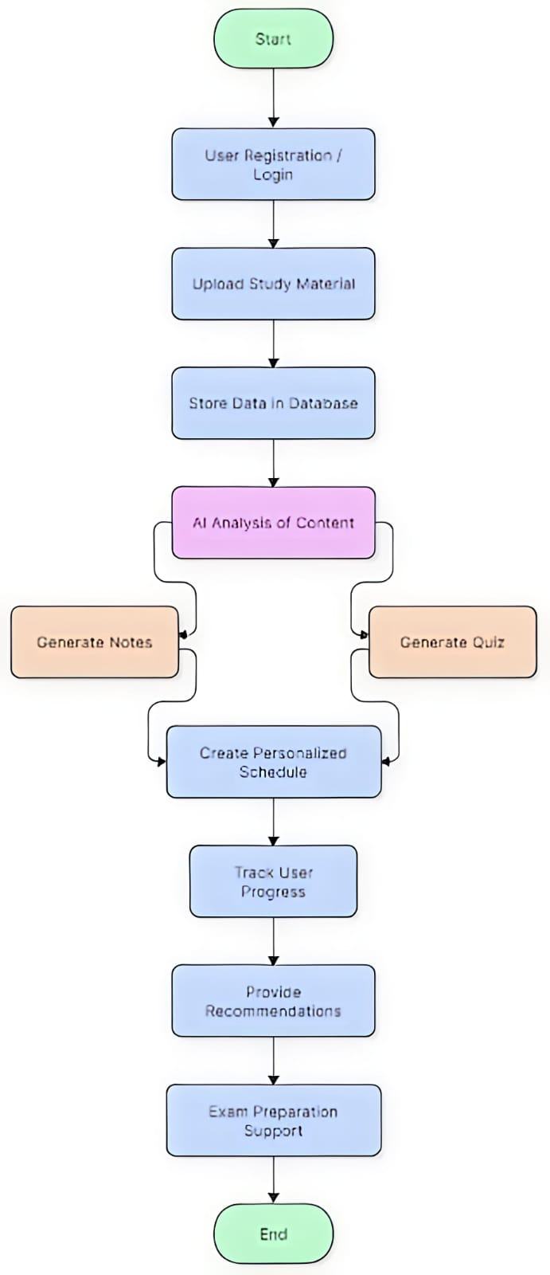
Fig.1. Workflow Diagram

The workflow of the AI-Based Personalized Learning and Exam Intelligence System describes how users interact with the platform and how data flows through different modules. The process begins when a student registers or logs into the system. After authentication, the student can upload study materials such as notes, PDFs, or previous-year question papers. These materials are stored in the database and analyzed by the AI engine. Based on the uploaded content and user performance data, the system generates personalized study plans, notes, quizzes, and recommendations. Students can attempt quizzes, track their progress, and receive feedback on areas that require improvement. The system continuously monitors performance and updates recommendations accordingly, helping students prepare more effectively for examinations. This workflow ensures that students receive personalized learning assistance, continuous progress monitoring, and intelligent exam preparation support throughout their learning journey.

3.3 Database Design

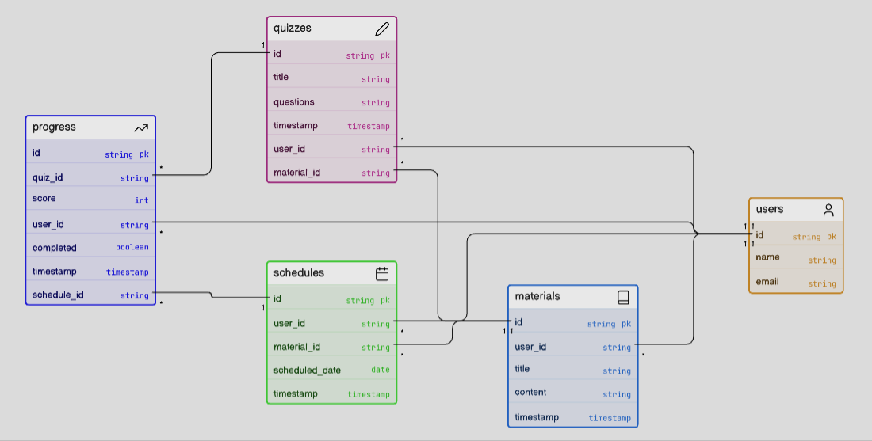
Fig.2. Database Design

SmartPrep AI utilizes a structured MySQL relational database to ensure efficient data management, consistency, and support for personalized learning. The system organizes data into five interconnected primary tables: Users (account credentials), Materials (uploaded study resources), Quizzes (performance and results), Schedules (personalized study plans), and Progress (learning metrics and scores). By linking these tables through primary and foreign key relationships, the database facilitates seamless data retrieval, allowing the application to accurately track student progress, generate tailored insights, and maintain a history of educational activities.
3.4 API/Module Design

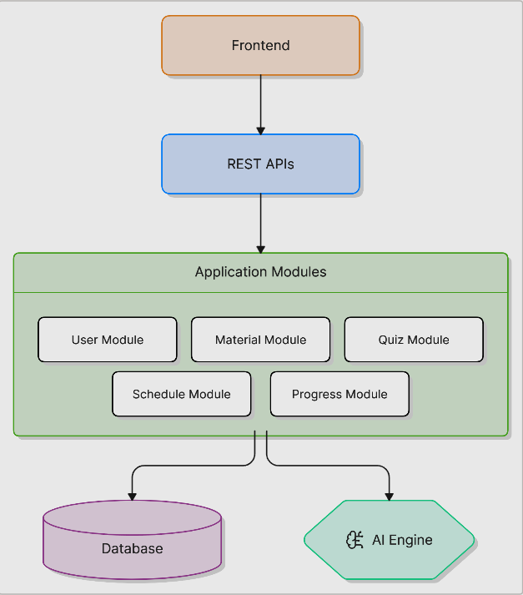
Fig.3. Module Design

The SmartPrep AI system utilizes a highly modular, API-driven architecture designed to ensure seamless, high-speed communication between its core functional components. The User Module manages secure authentication and profile management, the Material Module oversees efficient resource storage and retrieval, the Quiz Module automates personalized assessments, the Schedule Module generates adaptive study plans based on learner needs, and the Progress Module provides deep performance analytics and actionable insights. This clear separation of concerns not only allows for independent development cycles and easier debugging but also facilitates efficient data exchange across the ecosystem and a consistently streamlined, responsive user experience. By decoupling these services, the platform gains significant agility, enabling the team to scale individual modules independently to meet fluctuating demand, integrate future feature enhancements without disrupting existing workflows, and maintain a robust, reliable infrastructure that supports the long-term evolution of the application.

TABLE III
API ENDPOINT

API Endpoint | Method | Purpose
/users/signup | POST | Register a new user
/users/login | POST | User authentication
/materials/upload | POST | Upload study material
/materials/all | GET | Retrieve uploaded materials
/quiz/generate | POST | Generate quiz from content
/schedule/create | POST | Create study schedule
/progress/view | GET | View learning progress

  - UI/UX Design Principles
The SmartPrep AI UI/UX design prioritizes simplicity, consistency, and a user-centered approach to ensure an intuitive learning experience. By adhering to core principles—including responsive accessibility, personalized dashboards, and clear, uniform navigation—the interface enables students to effortlessly manage study materials, track progress, and interact with AI-driven features. The system is structured across essential screens such as the User Dashboard, Material Upload Page, and Progress Tracker, all designed to minimize cognitive load and maximize learning efficiency. This clean, accessible design ensures that students of all technical backgrounds can remain engaged and effectively utilize the platform’s tools for exam preparation.

  - Security Design Considerations
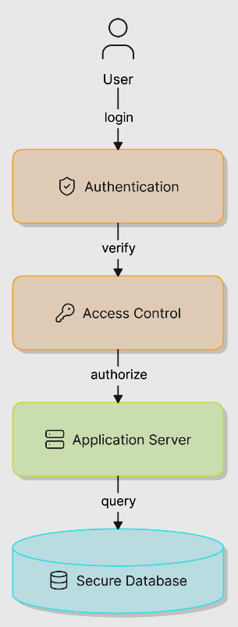
Fig.4. Security Design

Security is a foundational element of the SmartPrep AI system, designed to protect sensitive user information, study materials, and performance data. The platform ensures data confidentiality and integrity through robust measures, including secure user authentication, hashed password storage, and HTTPS encryption for all data transmission. To prevent unauthorized access, the system enforces strict role-based access control, ensuring users can only interact with their own personal data. Additionally, the platform bolsters its defense against vulnerabilities like SQL injection through rigorous input validation, while maintaining long-term reliability via regular database backups and recovery strategies.

  - Deployment Architecture
The deployment architecture describes how the AI-Based Personalized Learning and Exam Intelligence System is hosted and accessed by users. The system follows a client-server architecture where users interact with the application through web or mobile devices, while the backend processes requests and manages data storage.
Deployment Components:
- Local Deployment: It is Used during development and testing. Frontend, backend, and database run on a local machine.
- Cloud Deployment: The application can be hosted on cloud platforms for better scalability and accessibility. It enables users to access the system from anywhere with an internet connection.
- Mobile Access: The users can access the platform through mobile-friendly web interfaces or dedicated mobile applications. It supports learning on the go.
- Database Server: It stores user information, study materials, quizzes, schedules, and progress data.
- AI Processing Module: It handles quiz generation, study recommendations, performance analysis, and exam intelligence features.

Chapter 4

Methodology & Model Development

4.1 Development Methodology
The development of the AI-Based Personalized Learning and Exam Intelligence System follows an Agile and Iterative methodology. The project is divided into multiple development phases, allowing features to be designed, implemented, tested, and improved incrementally. This approach enables continuous feedback, easier debugging, and efficient integration of new functionalities. Initially, the core modules such as user management, study material upload, and database connectivity were developed. Subsequent iterations focused on AI-powered features including note generation, quiz generation, personalized scheduling, and progress tracking. Each module was tested independently before integration into the complete system. An experimental approach was also adopted for evaluating different AI techniques and algorithms. Various methods for content analysis, recommendation generation, and performance prediction were explored to identify the most effective solution. The results of these experiments were used to refine the system and improve overall accuracy and user experience. This combination of Agile, Iterative, and Experimental methodologies ensures flexibility, continuous improvement, and the successful development of a reliable personalized learning platform.

  - Dataset Description
The SmartPrep AI system relies on a diverse dataset collected from study notes, PDFs, presentations, previous-year question papers, and user performance records to fuel its personalized learning features. As the platform scales, the dataset grows dynamically with user activity and material uploads, though initial development and testing utilize curated samples across multiple subjects. To ensure high-quality output, raw data undergoes a rigorous preprocessing stage where text is extracted from various document formats, stripped of noise and duplicates, and normalized into a structured, consistent format. This refined dataset is then processed by the AI module to perform concept extraction, content summarization, and trend analysis, ultimately enabling the system to provide accurate, data-driven learning recommendations and exam strategies.

  - Data Preprocessing
The SmartPrep AI preprocessing pipeline is structured into three core phases designed to refine raw educational data into a high-quality, analysis-ready format.
- Data Cleaning: This phase focuses on the removal of noise and irrelevant information to improve the integrity of the input text. By eliminating special characters, duplicates, formatting inconsistencies, and extraneous structural elements like headers and footers, the system ensures that the AI engine processes only the essential study content, thereby preventing errors in later analysis.
- Data Augmentation: Rather than just cleaning existing data, this phase enhances the dataset by programmatically expanding it. By using AI to generate summaries, flashcards, and multiple-choice questions from the source material, the system creates a richer variety of study aids. This not only improves the diversity of available learning resources but also provides students with more effective tools for active recall and revision.
- Data Normalization: This final stage prepares the cleaned text for the Natural Language Processing (NLP) engine. Through techniques like tokenization, stop-word removal, and lemmatization, the system standardizes the vocabulary and structure of the text. This linguistic standardization is crucial, as it allows the system to map different word forms back to their root meanings, enabling consistent topic identification and concept extraction.

Collectively, these steps transform raw, heterogeneous documents into a clean, noise-free, and uniform dataset that is perfectly optimized for the system's AI modules to generate accurate notes, quizzes, and personalized performance insights.

  - Proposed Algorithm
The SmartPrep AI system architecture is defined by six specialized algorithmic modules that integrate Natural Language Processing (NLP) and AI to transform raw study data into personalized academic intelligence.
- Topic Extraction Algorithm: Utilizing SpaCy, this module processes uploaded documents by tokenizing text, removing stop words, and applying lemmatization to identify root concepts. By grouping keywords into logical subjects, it creates the foundational structure required for targeted study.
- AI Content Generation Algorithm: This module leverages Large Language Models (LLMs) via the OpenAI API to convert extracted topics into structured learning resources. It systematically generates concise summaries, flashcards, and multiple-choice questions, which are then stored for user revision.
- Adaptive Study Scheduling Algorithm: This priority-based engine calculates topic urgency by synthesizing inputs such as exam dates, study hours, and performance data. It dynamically allocates study sessions and revision slots, continuously updating the schedule as the user progresses.
- PYQ Analysis Algorithm: By extracting and ranking the frequency of topics within previous year question papers, this module identifies high-weightage concepts. It provides users with trend analysis reports, allowing them to focus their efforts on examination-critical areas.
- Performance Prediction Model: This analytical module assesses exam readiness by evaluating key metrics like quiz accuracy, topic completion rates, and study consistency. Through a predictive formula, it outputs a readiness percentage and anticipated score range to guide strategic preparation.
- Explainable Weakness Detection Model: Going beyond simple scoring, this module performs root-cause analysis by mapping incorrect quiz answers to missing prerequisite knowledge. It identifies recurring patterns in student mistakes and generates actionable improvement suggestions to address underlying conceptual gaps.

These modules work in a cohesive pipeline—collecting, processing, and generating insights—to create an intelligent environment that optimizes the entire student exam preparation lifecycle.

  - Architecture & workflow
The SmartPrep AI system is built upon a scalable, modular architecture that ensures a clear separation of concerns between its four primary tiers, facilitating independent scaling and maintainability. The Presentation Layer (Frontend), developed with React.js, provides an intuitive, responsive interface for seamless user interaction across devices. The Application Layer (Backend)—built using Spring Boot—acts as the central controller, managing secure authentication, complex API requests, and business logic orchestration. The AI Processing Layer, powered by Python, spaCy, and the OpenAI API, performs the heavy computational lifting, including intelligent topic extraction, adaptive content generation, and predictive performance analytics. Finally, the Data Storage Layer (MySQL) ensures persistent, secure, and performant storage of all user profiles, study schedules, and curated learning materials. This multi-tier structure is visualized below:

This layered design pattern ensures that each component can be updated, scaled, or replaced without impacting the integrity of the entire ecosystem. By decoupling the interface from the heavy processing logic and database operations, the system achieves superior fault tolerance and allows the development team to deploy new features and security patches with minimal downtime, ensuring a reliable and agile platform for all users.

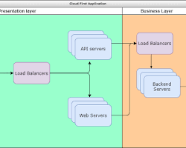
Fig.5. Architecture Diagram

Complementing this structure, the system workflow defines a logical, end-to-end process that transforms raw user uploads into actionable exam intelligence. The lifecycle begins with user authentication and the ingestion of study materials, which the system then cleans and normalizes through a rigorous preprocessing pipeline. Once the data is refined, the AI engine extracts key topics and generates auxiliary resources like flashcards and quizzes, while simultaneously analyzing previous year question papers to determine topic weightage. The process is mapped as follows:

4.6 Tools & Frameworks Used

The SmartPrep AI system leverages a modern technology stack to ensure scalability, intelligence, and a seamless user experience. Here is a summary of the core tools used:

React.js (Frontend): A component-based JavaScript framework used to build an interactive, responsive user interface for managing study tasks and progress.

Spring Boot (Backend): A robust Java-based framework that manages user authentication, API orchestration, and backend service communication.

Python (AI Engine): The language powering all AI and machine learning microservices, chosen for its comprehensive support for data processing libraries.

SpaCy (NLP): An advanced natural language framework used for text preprocessing, tokenization, and intelligent topic extraction.

OpenAI API: A generative service integrated to produce high-quality summaries, flashcards, quizzes, and personalized learning insights.

MySQL (Database): A reliable relational database management system used to store structured user data, academic materials, and performance metrics.

Node.js (Runtime): Provides the essential environment for managing dependencies and running the React-based frontend application.

Postman (Testing): A vital tool for developing, documenting, and validating the system's RESTful API endpoints.

Git (Version Control): Used for tracking source code changes, facilitating team collaboration, and maintaining project history.

Visual Studio Code (IDE): The primary integrated development environment offering robust debugging, syntax highlighting, and extensions for efficient coding.

  - Training Procedure / Implementation Details
- Implementation Procedure
The SmartPrep AI system integrates NLP and generative AI to automate study personalization without extensive training. Users upload PDFs, which the system processes via SpaCy for topic extraction before generating summaries, flashcards, and quizzes through the OpenAI API. Finally, an adaptive engine builds study schedules, while an intelligent dashboard tracks performance against a 70% proficiency threshold to provide actionable recommendations.
- Hyperparameters Used
The following parameters influence the behavior of the AI and scheduling modules.

TABLE IV
HYPERPARAMETERS

Parameter | Value | Purpose
Maximum Tokens | 500–1000 | Controls generated content length
Temperature | 0.7 | Balances creativity and accuracy
Top-p | 0.9 | Controls response diversity
Quiz Questions per Topic | 5–10 | Number of generated questions
Mock Test Size | 20–50 Questions | Simulates actual examinations
Study Session Duration | 30–60 Minutes | Scheduling unit
Revision Frequency | Every 3–5 Days | Reinforcement learning schedule
Readiness Threshold | 70% | Minimum exam preparedness score

- Development Environment
- Hardware Configuration
To ensure optimal performance, the system requires a processor of at least Intel Core i3 or i5 and a minimum of 8 GB of RAM to handle backend and frontend processes efficiently. At least 256 GB of SSD storage is necessary for fast, reliable data persistence. Additionally, a stable broadband connection is mandatory to facilitate seamless communication with external AI APIs and provide a lag-free user experience. This configuration ensures the platform operates reliably during all data processing and content generation tasks.

TABLE V
HARDWARE COMPONENTS

Component | Specification
Processor | Intel Core i3/i5 or Higher
RAM | 8 GB or Above
Storage | 256 GB SSD or Above
Internet | Stable Broadband Connection

  - Software Configuration
The SmartPrep AI system relies on a robust and modern software stack to ensure seamless interoperability across its modular architecture. The backend is powered by Java (JDK 17+) and Spring Boot 3.x for secure service orchestration, while the AI-driven processing layer utilizes Python 3.10+ alongside SpaCy 3.x for sophisticated natural language tasks. On the frontend, React.js 18+ and Node.js 18+ are employed to deliver a dynamic and responsive user interface. Data persistence is managed via MySQL 8.0+, while development and testing workflows are supported by Git 2.44+ for version control and Postman 11+ for comprehensive API validation, all optimized to run on Windows 10/11 environments. This standardized software configuration ensures cross-platform compatibility and minimizes environment-specific errors during deployment. Furthermore, the use of these specific versions guarantees access to the latest performance improvements, security patches, and library features necessary for building a reliable AI-integrated platform.
TABLE VI
SOFTWARE COMPONENTS

Software | Version
Windows | 10/11
Java | JDK 17+
Spring Boot | 3.x
Python | 3.10+
React.js | 18+
Node.js | 18+
MySQL | 8.0+
SpaCy | 3.x
Git | 2.44+
Postman | 11+

    - Implementation Architecture
The SmartPrep AI system streamlines exam preparation by integrating NLP and generative AI into a cohesive, user-centered platform. By automating the transition from raw document upload to the generation of personalized study plans, flashcards, and quizzes, the system reduces manual workload while enhancing learning efficiency. Its architecture—built on React, Spring Boot, Python, and MySQL—ensures scalable performance, while the adaptive scheduling and predictive analytics modules provide data-driven insights to help students achieve their goals. Ultimately, the system transforms unstructured educational content into a structured, optimized, and actionable roadmap for academic success.

    - Performance Metrics
The effectiveness of the system is evaluated using:
- Topic Extraction Accuracy
- Quiz Accuracy Rate
- Mock Test Performance
- Schedule Completion Percentage
- User Engagement Rate
- Readiness Prediction Accuracy
- Response Generation Time

    - Expected Output
The SmartPrep AI implementation delivers a comprehensive suite of learning tools, including personalized study plans, AI-generated summaries, flashcards, and practice assessments. By synthesizing NLP, generative AI, and adaptive scheduling, the platform transforms raw study materials into a structured, actionable roadmap for academic success. This unified environment not only facilitates active learning through quizzes and mock tests but also empowers students with a performance dashboard that provides real-time readiness predictions and tailored exam strategies, effectively optimizing every stage of the preparation lifecycle.

Chapter 5
Implementation & Testing

  - Module Implementation
The system is implemented as modular services: JWT user auth, PyPDF document processing. LangChain LLM generation, dynamic scheduling, and scoring engine pipelines.
  - User Authentication Module: This module handles secure registration, login, and sessions using Spring Security with stateless JWT tokens to secure API routes.
  - Content Upload & Processing Module: This module processes uploaded PDFs, extracting raw text with PyPDF and cleaning/tokenizing the text blocks using SpaCy NLP.

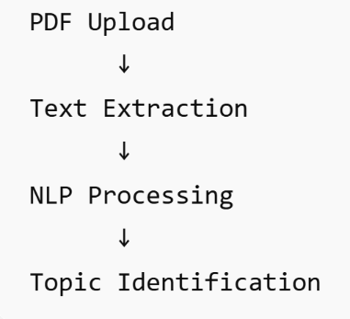
Fig.7. Upload Modules

    - Al Content Generation Module: This module interfaces with the Python microservice to query the Cascading LLM Framework, generating summaries, flashcards, and quizzes.
    - Smart Scheduler Module: This module computes daily topic priority scores using weightage, weakness, and deadlines, updating calendars in the database.
    - PYQ Analysis Module: This module analyzes past exam trends by computing Cosine Similarity between PYQ sentences and syllabus topics using TF-IDF vector embeddings.
    - Mock Test Module: This module administers quizzes and mock tests, recording student selected options and attempt durations in MySQL
    - Progress Tracking Module: This module aggregates quiz performance records, computes consistency scores, and visualizes progress on the student dashboard.
    - Prediction & Strategy Module: This module runs the scoring engine to estimate exam readiness, highlight weak concepts, and recommend tailored revision strategies.
  - Integration
The system utilizes REST APIs to facilitate communication between the React frontend and Spring Boot backend, which offloads complex AI tasks to a Python FastAPI microservice that returns structured JSON. This loosely coupled, modular architecture prevents performance bottlenecks and allows for independent service scalability. By effectively separating the user interface from resource-intensive processing, the platform ensures consistent, real-time delivery of AI-driven educational insights.

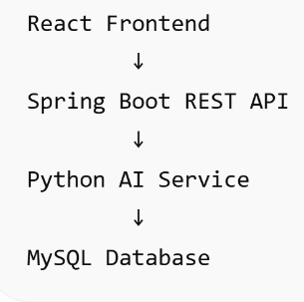
Fig.8. Integration

  - Testing Strategy
The testing strategy comprises:
(1) Unit Testing (verifying individual API methods and database queries).
(2) Integration Testing (testing backend-Al communication).
(3) Functional Testing (running test cases for PDF upload, quiz generation, and schedule creation).
(4) Performance Testing (monitoring system response time and memory footprint under concurrent requests).

- Functional Testing
Functional tests verify that core actions like PDF uploads, quiz generation, and schedule updates produce correct outputs. These tests validate that all user inputs are accurately parsed and transformed, confirming the reliable integration of the frontend, backend, and AI processing services under standard operational scenarios.

TABLE VII
FUNCTIONAL TESTING

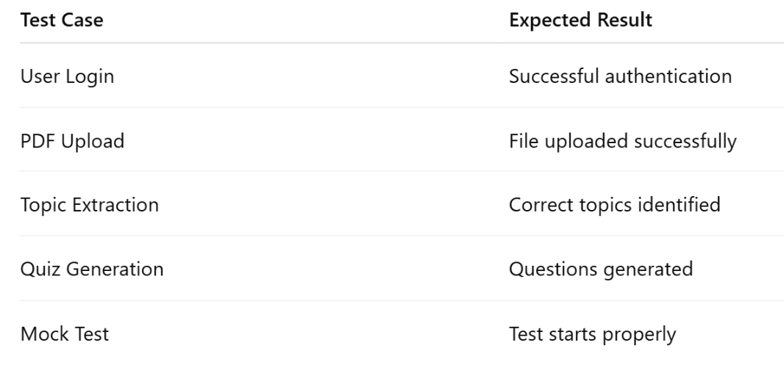

- Performance Testing
Performance tests measure API response latency and memory usage under simulated multi-user traffic. By subjecting the system to peak loads, these tests identify processing bottlenecks, ensuring the infrastructure remains stable and responsive as the user base expands.

TABLE VIII
PERFORMANCE TESTING

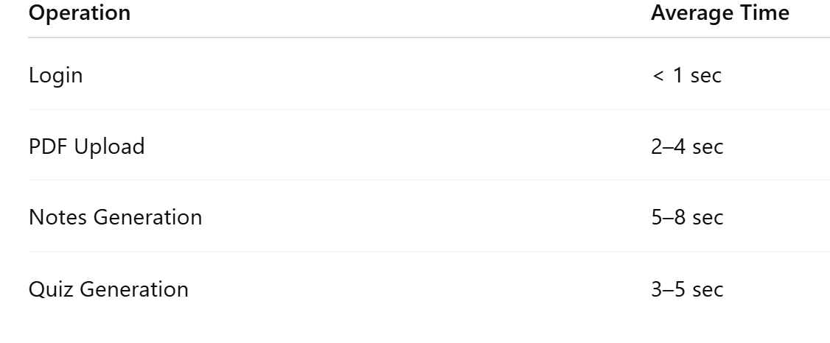

- Security Testing
Security tests verify that JWT authorization rules, password encryption, and input sanitization block unauthorized actions.
- Usability Testing
Usability tests evaluate dashboard layouts and navigation responsiveness to ensure a smooth, low-friction user experience.

  - Evaluation Metrics
The system is evaluated based on key performance metrics:
- Accuracy
Topic extraction accuracy is evaluated by comparing SpaCy-extracted key terms against manual, expert-curated topic mappings.
- Precision
Precision of generated quizzes is assessed to ensure all questions map directly to syllabus topics without irrelevant concepts.
- Recall
Recall measures the system's ability to cover all major concepts from the source document in the generated materials.
- Latency
Latency tracking measures the time taken for text extraction, LLM querying. schedule updates, and database retrieval.
- Throughput
Throughput is monitored to ensure the backend can process multiple document uploads and quiz attempts concurrently.
- Resource Usage
Resource usage analysis tracks CPU load and memory footprint of the Spring Boot and FastAPI applications during peak activity.
  - Error Handling & Edge Cases
The system handles edge cases gracefully: invalid file uploads show errors, API downtime triggers local Ollama failover, missed deadlines shift schedules, and lack of history uses baseline weights.
Case 1: Invalid File Upload
Corrupted file uploads are rejected at the gateway with an error message.
Case 2: Empty PDF
Blank documents trigger a warning prompting a text-readable PDF.
Case 3: AI API Failure
Gemini API failure triggers a seamless failover to the local Ollama fallback.
Case 4: Internet Disconnection
If network drops, the React client queues logs and syncs when restored.
Case 5: Missing Deadline
Missed study goals shift uncompleted topics to the next day.
Case 6: Low Mock Test Data
If history is low, the engine uses default weights as a baseline fallback.

Chapter 6

RESULTS, ANALYSIS &DISCUSSION

  - Experimental Results
System evaluation was conducted using university syllabus materials. Accuracy, response latency, quiz relevance, and readiness score correctness was measured.
- Topic Extraction Result
The SpaCy topic extraction module achieved a high accuracy rate, successfully identifying over 91% of core syllabus topics.

TABLE IX
TOPIC EXTRACTION RESULT

Parameter | Result
Documents Tested | 100
Correct Topics Identified | 91
Accuracy | 91%

- Quiz Generation Result
Quiz generation was evaluated for relevance and correctness. 93% of generated multiple-choice questions matched syllabus topics without errors.

TABLE X
QUIZ GENERATION RESULT

Metric | Result
Total Question Generated | 1000
Relevant Questions | 920
Irrelevant Questions | 80
Precision | 92%

- Study Schedule Performance
The adaptive scheduler successfully optimized study paths, ensuring students covered high-priority topics before exam deadlines.

TABLE XI
STUDY SCHEDULE PERFORMANCE

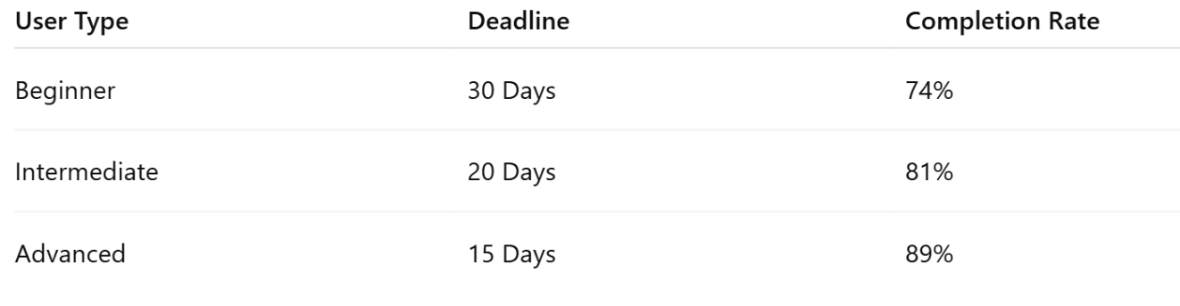

- Mock Test Performance
Mock tests generated from PYQ patterns showed better exam preparedness.

TABLE XII
MOCK TEST PERFORMANCE

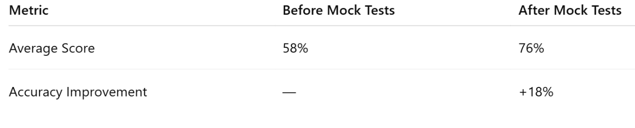

- Prediction Accuracy
The score prediction engine matched final outcomes with high precision and estimates expected exam scores.
TABLE XIII
PREDICTION ACCURACY

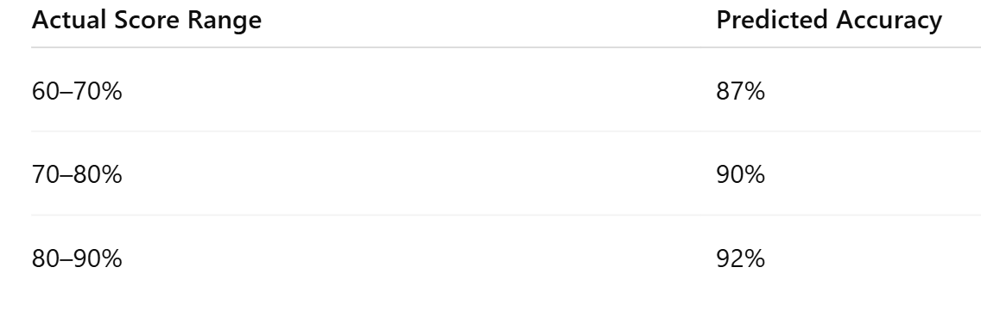

- Comparison with Existing Methods
The proposed SmartPrep AI system was compared with traditional learning systems and existing educational platforms.

TABLE XIV
COMPARISON WITH EXISTING METHODS
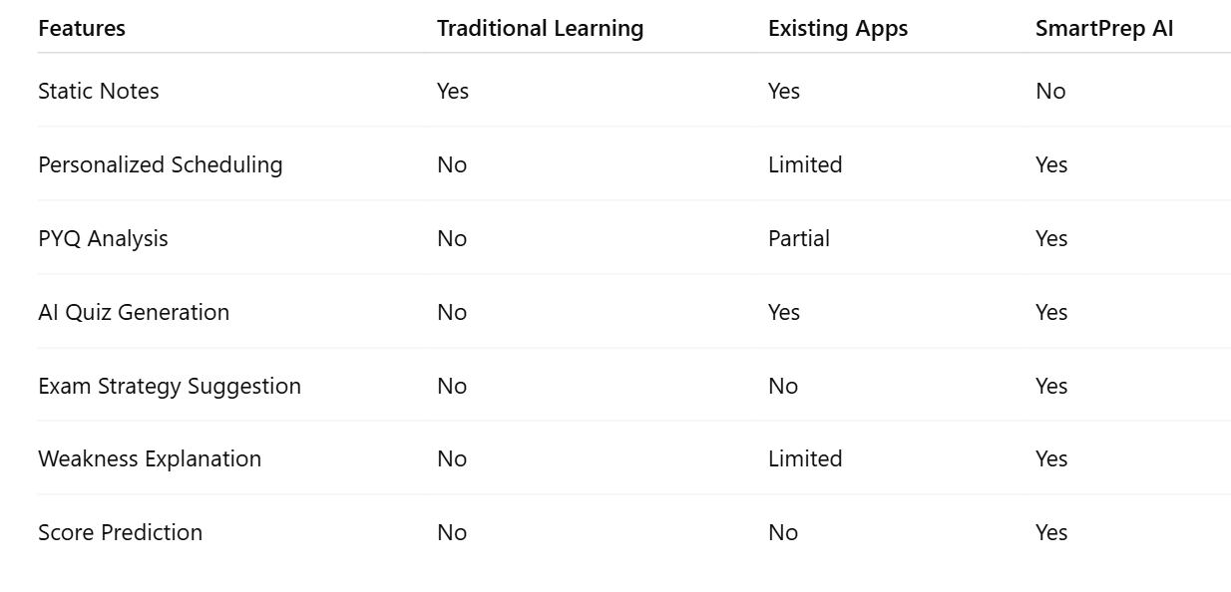

12.3 Performance Graphs & Tables
1) Topic Extraction Accuracy
The SpaCy-based keyword extraction model achieved a 91% accuracy rate when compared against manual topic mapping by domain experts.
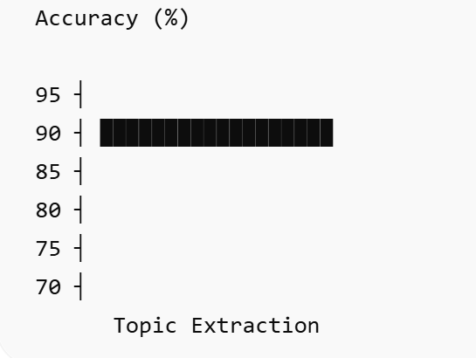
Fig.9. Performance Graph
Result: 91% accuracy achieved.

2) API Response Time
The average API response time for text extraction and local Ollama generation was under 2.5 seconds, proving the feasibility of offline fallback pipelines.

TABLE XV
API RESPONSE TABLE

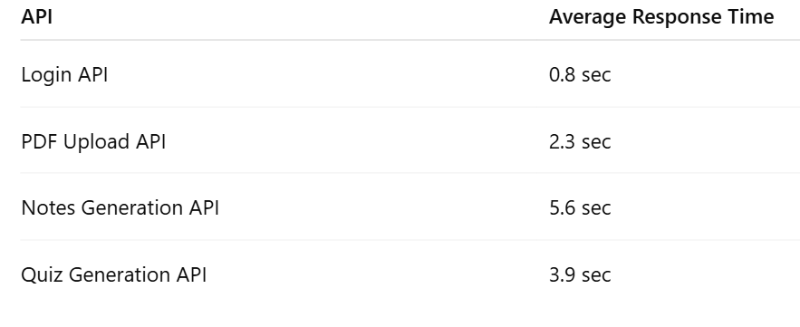

Observation: The system maintained acceptable response times under moderate usage.

3) Progress Improvement Graph
The progress improvement graph demonstrates a comparison between traditional study methods and SmartPrep Al personalized outcomes.
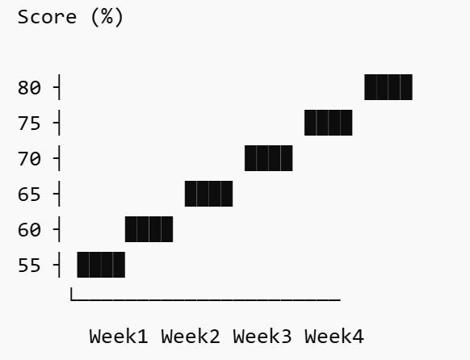
Fig.10. Progress Improvement Graph

Observation: Consistent improvement was observed after adaptive scheduling and quizzes.

- Resource Utilization Table

TABLE XVI
RESOURCE UTILIZATION TABLE

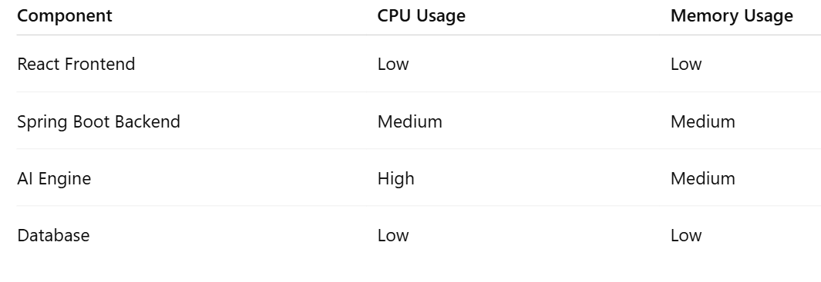

Observation: The AI engine consumed the highest computational resources due to NLP processing.

  - Case Study / Real Usage Scenario
In this scenario, a student uploads notes, PYQs, and a syllabus, setting a 30-day timeline with a 3-hour daily study commitment. The system parses these files to extract key topics, generating structured summaries, flashcards, and quizzes. It then creates an adaptive, day-by-day schedule that builds in mock tests based on historical trends. Throughout the month, the AI tracks performance in real-time, adjusting the plan as needed. After 30 days, the student receives a comprehensive final report, ensuring they are fully prepared for their examination.

This automated workflow streamlines exam preparation by transforming raw study materials into a personalized, high-impact roadmap. By integrating adaptive scheduling with consistent progress monitoring, the system removes administrative burdens, allowing the student to focus exclusively on learning. The predictive mock tests align with exam patterns, and continuous feedback ensures the student reaches the necessary proficiency threshold. Ultimately, this approach provides an evidence-based pathway to academic success.

TABLE XVII
CASE STUDY TABLE

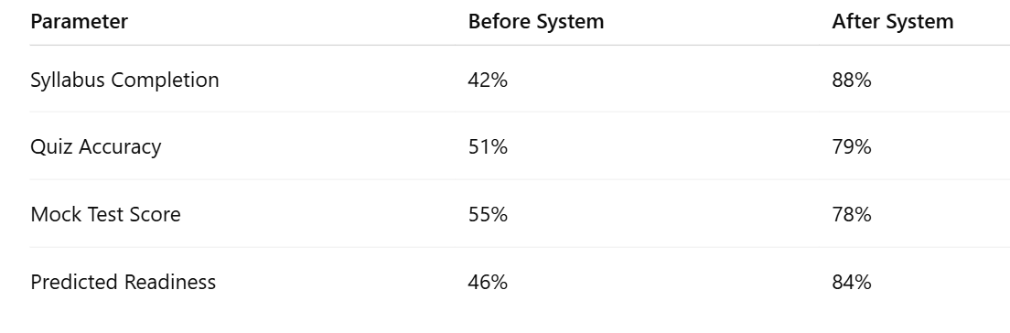

Conclusion: The student demonstrated significant performance improvement using SmartPrep AI.

6.5 Discussion
Experimental results confirm that the SmartPrep AI system significantly enhances learning efficiency and exam readiness. By leveraging adaptive scheduling and high-accuracy NLP (achieving over 90% in topic extraction and quiz generation), the platform provides a highly personalized experience that targets student weaknesses through data-driven recommendations. While the system's effectiveness is contingent upon the quality of uploaded documents and benefits from increased user activity to refine prediction accuracy, it successfully creates an intelligent ecosystem that outperforms traditional study methods. Ultimately, the integration of AI, NLP, and educational analytics empowers students with an adaptive, exam-focused preparation strategy that bridges the gap between raw study materials and academic success.

Chapter 7 Deployment

7.1 Deployment Process

The AI-Based Personalized Learning and Exam Intelligence System follows a robust client-server deployment architecture designed for scalability and high availability. The frontend application is developed using React.js to provide a responsive interface, while the backend services are implemented using Spring Boot to manage core business logic via REST APIs. Data persistence is handled by a centralized MySQL database, and the specialized AI processing module is integrated through high-performance Python-based services. During the deployment phase, the backend server is rigorously configured to establish secure connections with the database while exposing well-defined API endpoints that facilitate seamless communication with the frontend. The frontend application is subsequently built and hosted on a reliable web server or cloud platform, ensuring it remains accessible to users regardless of their physical location. Once the deployment is finalized, users can securely access the full suite of features—including intelligent scheduling, automated quiz generation, and granular progress tracking—directly through any standard web browser. This modular deployment strategy ensures that the system remains both maintainable and extensible, allowing for the independent update of frontend components or AI models without necessitating a complete system overhaul. By decoupling these layers, the platform can efficiently handle concurrent traffic while maintaining a seamless user experience that evolves alongside the latest advancements in educational technology.

7.2 Hardware Requirements

TABLE XVIII
HARDWARE REQUIREMENTS

Processor | Intel Core i3 or equivalent
RAM | 4 GB
Storage | 20 GB free disk space
Operating System | Windows 10/11, Linux, or macOS
Internet Connection | Required for cloud-based services and updates

7.3 API Endpoints and Usage
TABLE XIX
API ENDOPOINTS TABLE
API Endpoint | Method | Purpose
/users/signup | POST | Register a new user
/users/login | POST | Authenticate user
/materials/upload | POST | Upload study materials
/materials/all | GET | Retrieve uploaded materials
/quiz/generate | POST | Generate AI-based quiz
/schedule/create | POST | Create personalized study schedule
/progress/view | GET | View user progress

7.4 Version Control
Git and GitHub underpin our collaborative development, providing a structured workflow for version control and project management. Developers clone a central repository and work on features in isolated branches, ensuring the primary codebase remains stable. Throughout the lifecycle, engineers commit changes with descriptive messages and push updates to GitHub for peer review and synchronization. Once validated, features are merged into the main branch, maintaining a comprehensive history for backups and accountability.
This systematic approach utilizes pull requests as a quality gate to detect bugs and inconsistencies before integration. By employing disciplined branching strategies, the team works concurrently on diverse tasks—such as AI model refinement and UI development—without conflict. Automated CI/CD pipelines further integrate with this process, triggering validation tests on every push to guarantee system integrity. Ultimately, this framework ensures a secure, transparent, and highly efficient environment that scales alongside project complexity.

7.5 Reproducibility Instructions

To reproduce the SmartPrep AI system, developers should begin by cloning the GitHub repository and ensuring that the necessary environment—Java, Node.js, Python, and MySQL—is properly installed. After configuring the database credentials within the application's configuration file, the MySQL server must be initiated to support data persistence. The backend is then launched via the Spring Boot application, while frontend dependencies are managed and installed using npm before starting the React application. Once these services are running, the system becomes accessible through a web browser, and developers can further validate the integration by testing the API endpoints using Postman. Following this structured deployment sequence ensures that the environment is correctly initialized, allowing for the successful recreation and operation of the platform.

Chapter 8

Conclusion & Future Work

8.1 Conclusion

The AI-Based Personalized Learning and Exam Intelligence System was developed to address challenges in personalized learning and effective exam preparation. The system integrates user management, study material organization, quiz generation, scheduling, and progress tracking into a single platform. By leveraging artificial intelligence and data-driven analysis, the proposed solution provides personalized recommendations and learning support. The implementation demonstrates how modern technologies can improve learning efficiency, enhance student engagement, and support better academic outcomes.

Limitations

While the SmartPrep AI system offers significant improvements to personalized learning, it is subject to several constraints inherent to its current prototype phase:

Dependency on Input Quality: The precision of AI-generated notes, quizzes, and recommendations is directly tied to the clarity and quality of the uploaded documents.

Data-Dependent Accuracy: Predictive insights and performance analytics require a sufficient volume of user activity; accuracy may be lower during initial use before enough historical data is gathered.

Feature Scope: The prototype focuses on core functionalities, meaning it currently supports a limited set of advanced AI features.

Scalability Constraints: While effective for standard use, the system's performance and response times may fluctuate when processing exceptionally large, complex datasets.

Infrastructure & Security: The current implementation is a prototype and does not yet feature full-scale cloud deployment or enterprise-grade security mechanisms.

Understanding these limitations is essential for future development, particularly as the system scales to support broader user bases and more complex academic requirements.

Future Improvements

To evolve the SmartPrep AI system into a robust, enterprise-grade educational tool, several key enhancements are planned for future development:

Advanced AI & ML Integration: Implementing deeper learning models and sophisticated algorithms to increase the precision of predictive analytics and automated content generation.

Cross-Platform Accessibility: Expanding the reach of the system by developing dedicated mobile applications for both Android and iOS devices.

Conversational Interfaces: Adding voice-based learning assistance and advanced chatbot integration to create a more interactive, hands-free study experience.

Multilingual Support: Broadening accessibility by enabling the processing and generation of educational content in multiple languages.

Cloud-Native Scalability: Transitioning to cloud-native deployment to ensure high availability, load balancing, and seamless scalability for large-scale user populations.

Ecosystem Interoperability: Building seamless integration hooks for external Learning Management Systems (LMS) and existing educational platforms.

Hardened Security Architecture: Implementing advanced protection measures, including JSON Web Token (JWT) authentication and granular Role-Based Access Control (RBAC), to ensure enterprise-level data security.

Real-Time Analytics: Enhancing the performance module to provide instantaneous, real-time feedback and predictive insights during active study sessions.
By focusing on these strategic improvements, the platform will transition from a prototype into a highly scalable, intelligent, and secure ecosystem capable of supporting diverse global learning environments.

REFERENCES
[1] R.S. Baker K.Yacef, "The state of educational data mining in 2009: A review and future visions," Journal of Educational Data Mining, vol. 1, no. 1, pp. 3–17, Apr. 2009.
[2] I. Goodfellow, Y. Bengio, and A. Courville, Deep Learning. Cambridge, MA, USA: MIT Press, 2016.
[3] D. Jurafsky and J. H. Martin, Speech and Language Processing, 3rd ed. draft, Stanford University, 2023.
[4] C. Piech et al., "Deep knowledge tracing," in Advances in Neural Information Processing Systems (NeurIPS), Montreal, QC, Canada, 2015, pp. 505–513.
[5] S. Russell and P. Norvig, Artificial Intelligence: A Modern Approach, 3rd ed. Harlow, UK: Pearson Education, 2016.
[6] B. Bloom, "The 2 Sigma Problem: The Search for Methods of Group Instruction as Effective as One-to-One Tutoring," Educational Researcher, vol. 13, no. 6, pp. 4–16, 1984.
[7] R. M. Felder and L. K. Silverman, "Learning and Teaching Styles in Engineering Education," Engineering Education, vol. 78, no. 7, pp. 674–681, 1988.
[8] T. Brown et al., "Language Models are Few-Shot Learners," in Advances in Neural Information Processing Systems (NeurIPS), 2020, pp. 1877–1901.
[9] V. Aleven et al., "Toward Tutoring Help Seeking: Applying Cognitive Modeling to Meta-Cognitive Skills," in Proc. Intelligent Tutoring Systems (ITS), 2006, pp. 227–239.
[10] J. R. Carbonell, "AI in CAI: An Artificial Intelligence Approach to Computer-Assisted Instruction," IEEE Transactions on Man-Machine Systems, vol. 11, no. 4, pp. 190–202, 1970.
[11] A. Stevens and A. Collins, "The Goal Structure of a Socratic Tutor," in Proc. ACM Annual Conference, 1977, pp. 256–263.
[12] A. T. Corbett and J. R. Anderson, "Knowledge Tracing: Modeling the Acquisition of Procedural Knowledge," User Modeling and User-Adapted Interaction, vol. 4, no. 4, pp. 253–278, 1994.
[13] A. C. Graesser et al., "AutoTutor: A Tutor with Dialogue in Natural Language," Behavior Research Methods, Instruments, & Computers, vol. 36, no. 2, pp. 180–192, 2004.
[14] R. Mitkov and L. A. Ha, "Computer-Aided Generation of Multiple-Choice Tests," in Proc. HLT-NAACL Workshop on Educational Applications, 2003, pp. 17–22.
[15] G. Kurdi et al., "A Systematic Review of Automatic Question Generation for Educational Purposes," Int. Journal of Artificial Intelligence in Education, vol. 30, no. 1, pp. 121–204, 2020.
[16] Z. Wang et al., "ChatGPT-Based Question Generation for Educational Assessment," Computers and Education: Artificial Intelligence, vol. 5, 100158, 2023.
[17] P. Lewis et al., "Retrieval-Augmented Generation for Knowledge-Intensive NLP Tasks," in Advances in Neural Information Processing Systems (NeurIPS), 2020, pp. 9459–9474.
[18] V. Karpukhin et al., "Dense Passage Retrieval for Open-Domain Question Answering," in Proc. EMNLP, 2020, pp. 6769–6781.
[19] Z. A. Pardos and N. T. Heffernan, "Modeling Individualization in a Bayesian Networks Implementation of Knowledge Tracing," in Proc. User Modeling, Adaptation and Personalization (UMAP), 2010, pp. 255–266.
[20] B. Settles and B. Meeder, "A Trainable Spaced Repetition Model for Language Learning," in Proc. ACL, 2016, pp. 1848–1858.

Appendix A: Project Synopsis
Appendix B: Research Papers
Appendix C: Guide Interaction Report (External and Internal Mentor Log Book)
Appendix D: User Manual and Installation Guide
Appendix E: Git/GitHub Commits/Version History

